L&T INTERNSHIP COMPLETION REPORT

Team Details
Names: Harshdeep Sharma, Sastha Rupan.S, Nesha Kirana Raju, Sushmitha Shyam Prasad.
Internship Duration: 30 Days

Internship Details
Start Date: 06 April 2026
End Date: 05 May 2026
Duration: 30 Days
Domain: Cybersecurity

Mentor And Institution Details
Academic Institution: Christ University, Bangalore
Corporate Partner: L&T
Mentor Name: Dhikhi T

1. Project Title
Password Strength Analyzer with AI Visual Mnemonics.

2. Executive Summary & Objectives
2.1 Executive Summary
In the modern cybersecurity landscape, human memory remains the weakest link in identity and access management (IAM). While cryptographic standards demand complex, high-entropy passwords, users consistently default to predictable patterns (e.g., dictionary words, personal dates, sequential numbers) to maintain cognitive ease. This discrepancy leads to catastrophic vulnerabilities, primarily targeted through brute-force attacks, credential stuffing, and social engineering.
The Password Strength Analyzer with AI Visual Mnemonics is an enterprise-grade web application engineered to bridge the gap between high-level cryptographic security and user accessibility. By shifting the cognitive burden from complex character strings to highly memorable, AI-generated visual anchors, the system fundamentally alters how users interact with secure credentials.
The application architecture is divided into two primary environments:
- The Client Node (Frontend): A "Glassmorphism" interface featuring a Core Evaluation Engine (zxcvbn.js) for algorithmic entropy analysis, and a Threat Intelligence Layer that utilizes Natural Language Processing (compromise.js) to actively scan for and warn against the use of localized personal data. Furthermore, a client-side k-Anonymity protocol securely verifies credentials against billion-record breach databases (Have I Been Pwned API) without exposing raw data.

- The Zero-Trust Vault (Backend): A high-performance Python/FastAPI server integrating a local, GPU-accelerated Generative AI model (stabilityai/sd-turbo) to synthesize detailed visual mnemonics. The backend is heavily fortified with AES-256 symmetric data-at-rest encryption, Bcrypt zero-knowledge authentication, IP-based rate limiting (slowapi), and an immutable audit logging engine for compliance tracking.
2.2 Executive Summary
The primary objective of this internship project was to conceptualize, design, and deploy a full-stack security architecture that mitigates human-centric vulnerabilities while maintaining strict, commercial-grade backend compliance.
The specific technical objectives achieved include:
- Mitigating Targeted Attacks: Implementing NLP-driven active scanning to prevent the utilization of personally identifiable information (PII) within passwords.
- Enhancing Cognitive Retention: Developing an AI Transformation Engine that utilizes local Generative AI to create visual mnemonics, drastically improving the recall rate of high-entropy credentials.
- Establishing a Zero-Trust Environment: Engineering a backend vault that operates on the principle of "never trust, always verify," utilizing isolated environment variables (.env) and cryptographic hashing (bcrypt) to ensure master admin credentials are never stored in plain text.
- Securing Data at Rest: Implementing military-grade AES-256 symmetric encryption for all sensitive user credentials and base64-encoded visual assets prior to cloud database storage.
- Deploying Active Defenses: Developing a Brute-Force Shield via strict IP rate-limiting to automatically detect, drop, and ban automated guessing scripts targeting the decryption API.
- Ensuring Enterprise Compliance: Engineering an immutable, non-repudiable audit logging system that records every API interaction (timestamp, IP, target, status) to a segregated MongoDB collection, accessible only via a restricted Admin Decryption Portal.

3. Problem Statement
The Core Problem: Human Memory vs. Cryptographic Complexity
The fundamental crisis in modern Identity and Access Management (IAM) is the inherent conflict between cryptographic security requirements and human cognitive limitations. To withstand automated decryption attacks, a secure system demands credentials with high entropy—typically long, randomized strings containing a mix of alphanumeric characters and special symbols.
However, the human brain is not optimized for retaining random, abstract data. When forced to create complex passwords without assistance, users inevitably resort to predictable, formulaic patterns to maintain cognitive ease. This includes utilizing localized personal data (such as hometowns or birth years, e.g., "Chennai2026"), sequential keyboard patterns ("qwerty", "123456"), or reusing the same password across multiple platforms. Consequently, human memory becomes the weakest link in the security perimeter, effectively neutralizing the underlying cryptographic defenses of the systems they interact with.

4. The Threat Landscape
Threat actors exploit these predictable human behaviors utilizing a highly automated and sophisticated attack ecosystem. The Password Strength Analyzer was engineered specifically to neutralize the following primary attack vectors:
- Dictionary and Brute-Force Attacks: Automated scripts systematically cycle through massive lists of common words, phrases, and predictable character substitutions (e.g., replacing 'a' with '@'). Because users frequently rely on standard dictionary words to aid memory, these attacks remain highly effective against traditional authentication portals.
- Targeted Social Engineering & OSINT: Attackers increasingly utilize Open-Source Intelligence (OSINT) to scrape Personal Identifiable Information (PII) from social media and public records. By feeding a user’s name, location, family details, and significant dates into custom password-generation algorithms, attackers can bypass standard security gates. Traditional password strength meters evaluate mathematical entropy but completely fail to contextualize the password against the specific user's life.
- Credential Stuffing & Breach Exploitation: Due to widespread password reuse, a compromise on a low-security third-party site often grants attackers the keys to high-value enterprise accounts. Attackers deploy automated botnets to rapidly "stuff" known breached credentials into major authentication portals. If a system does not actively cross-reference incoming credentials against known global breaches, it remains blind to this widespread attack vector.
4.1 he Need for a Cognitive, Zero-Trust Paradigm
Traditional security tools attempt to solve these issues by enforcing strict password policies, which paradoxically leads to higher rates of password amnesia, written-down passwords (physical breaches), and help-desk resets.
A modern solution requires a paradigm shift: Cognitive Security combined with Zero-Trust Architecture.
- Cognitive Security: The system must actively assist the user in generating high-entropy credentials that are anchored to vivid, easily recallable concepts (Visual Mnemonics), eliminating the need for predictable formulas.
- Zero-Trust Architecture: The underlying vault managing these identities must operate under the assumption that the network is always hostile. It must cryptographically secure all data at rest, hash all master access keys, and rigorously monitor and throttle incoming connection attempts to detect and repel automated attacks in real time.

5. System Architecture - Tech Stack
5.1 High-Level Architectural Flow
The Password Strength Analyzer with AI Visual Mnemonics is built upon a decoupled, two-tier architecture: a lightweight, client-side frontend (The Client Node) and a heavily fortified, asynchronous backend (The Zero-Trust Vault). This separation of concerns ensures that heavy computational tasks (like NLP scanning and cryptographic hashing) are distributed, while sensitive operations (like AES encryption and AI generation) are isolated within a secure server environment.
The system utilizes a RESTful API design over HTTP/1.1, facilitating seamless JSON data payloads between the client and server. The architecture is explicitly designed to handle asynchronous requests, preventing the backend from blocking during resource-intensive tasks such as local AI image generation or cloud database queries.
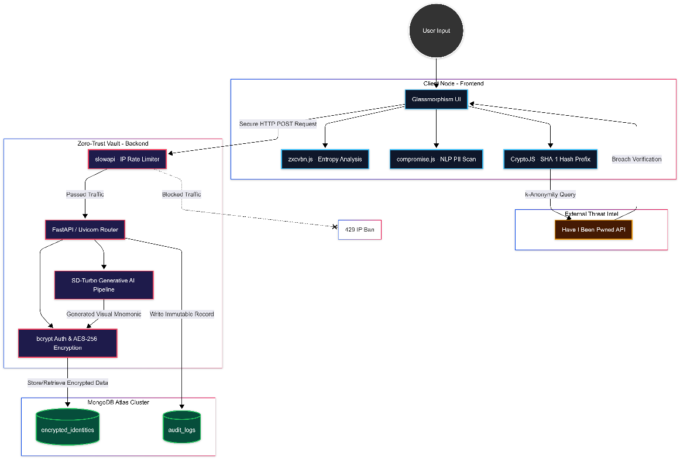
(Figure 5.1: High-Level System Architecture detailing the data flow from the Client Node through the FastAPI endpoints, branching into the Security/Encryption layer and the Generative AI pipeline, before terminating at the MongoDB Atlas Cluster.)

5.2 The Client Node (Frontend Edge)
The frontend is designed to be the first line of defense, performing critical security evaluations locally in the user's browser before any data is transmitted across the network.
- UI/UX Design Framework: The interface is built using HTML5, CSS3, and Vanilla JavaScript (ES6+), employing a modern "Glassmorphism" aesthetic. This visual approach utilizes translucent panels and dynamic blurring to create a high-tech, engaging user experience that encourages interaction with the security tools.
- Core Evaluation Engine (zxcvbn.js): Instead of relying on outdated regex-based password rules (e.g., requiring one uppercase letter), the client utilizes Dropbox's zxcvbn library. This algorithm evaluates password entropy by pattern-matching against a massive local dictionary of common names, pop culture references, and keyboard patterns, providing a realistic crack-time estimation.
- NLP Threat Scanning (compromise.js): To prevent targeted social engineering attacks, the frontend uses Natural Language Processing to actively parse user inputs. It cross-references proposed passwords against the user's localized contextual data (names, locations) to ensure no Personal Identifiable Information (PII) is utilized in the credential.
- k-Anonymity Breach Verification: The frontend integrates the Have I Been Pwned (HIBP) API. Utilizing CryptoJS, the system generates a SHA-1 hash of the password locally, sending only the first 5 characters (the prefix) to the API. This k-Anonymity protocol ensures the system can check billion-record breach databases without ever transmitting the user's actual password.
5.3 The Zero-Trust Vault (Backend Core)
The backend is the administrative and cryptographic engine of the application, operating under strict Zero-Trust principles where no incoming request is inherently trusted.
- API Framework (Python / FastAPI): The core routing is handled by FastAPI, running on an ASGI server (Uvicorn). FastAPI was selected for its high performance, native support for asynchronous programming (async/await), and automatic data validation via Pydantic models.
- Access Control & Rate Limiting (slowapi): To mitigate automated brute-force and dictionary attacks targeting the decryption endpoints, the backend utilizes slowapi (based on an IP memory structure). Requests exceeding the configured threshold (e.g., 5 requests per minute) are immediately intercepted, dropping the connection and issuing an HTTP 429 (Too Many Requests) response.
- Cryptographic Libraries: The backend relies on two distinct cryptographic pipelines. Symmetrical data-at-rest encryption is handled by cryptography.fernet (AES-256), while one-way password hashing for the Master Admin authentication is executed using bcrypt, completely isolating plain-text secrets from the source code via .env configurations.

5.4 Generative AI Pipeline (Local Inference)
A distinguishing feature of this architecture is the local execution of Generative AI, completely bypassing the need for third-party API dependencies (like OpenAI) which pose data privacy risks for security applications.
- Model Architecture: The backend utilizes stabilityai/sd-turbo via the HuggingFace diffusers library. This is a state-of-the-art text-to-image synthesis model optimized for rapid generation.
- Hardware Acceleration: The Python pipeline is configured to automatically detect and utilize local GPU hardware via PyTorch (torch.float16 and CUDA execution). In the event a GPU is unavailable, the pipeline features a graceful fallback to CPU inference.
5.5 Database Subsystem
Data persistence is managed via a NoSQL cloud infrastructure, providing high availability and flexible schema design.
- MongoDB Atlas Cluster: The application utilizes pymongo to interface with a remote MongoDB cluster. The database is heavily restricted, utilizing IP whitelisting and strictly segregated collections.
- Collection Segregation: To maintain data hygiene and compliance, the database is split into two primary collections:
  - encrypted_identities: Stores the AES-encrypted user credentials and base64 AI mnemonic strings.
  - audit_logs: An append-only collection that tracks immutable metadata for every vault interaction (IP, timestamp, target, status code) for security auditing.
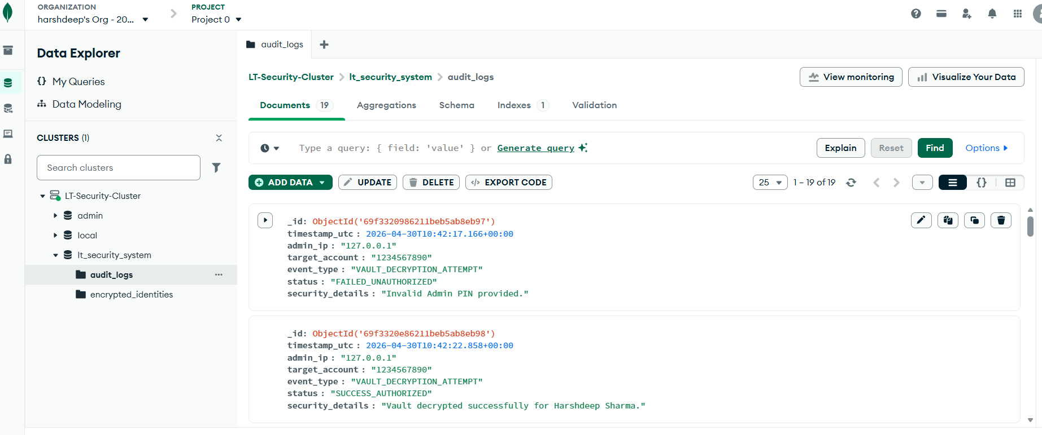
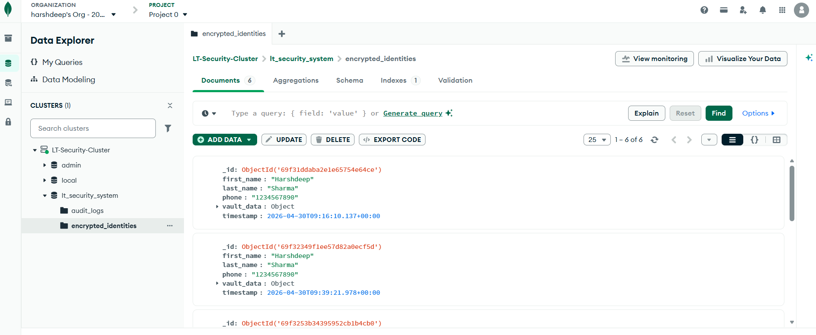
(Figure 5.2: NoSQL schema demonstrating the segregation of encrypted vault assets from the immutable audit logging collection within MongoDB Atlas.)

6. Core Infrastructure
To ensure the system meets commercial compliance standards, the architecture was fortified with a multi-layered security model. This section outlines the specific cryptographic implementations and active defense mechanisms engineered into the Zero-Trust Vault.
6.1 Data-at-Rest Encryption (AES-256)
A fundamental tenet of Zero-Trust architecture is assuming that the database could eventually be compromised. Therefore, no sensitive data is ever stored in plain text within the MongoDB Atlas cluster.
To achieve this, the backend utilizes the cryptography.fernet module to implement Advanced Encryption Standard (AES) in CBC mode with a 128-bit block size and a 256-bit key (AES-256).
- Symmetric Encryption: The system utilizes a symmetric key securely stored in the .env file.
- The Encryption Pipeline: When a user generates an AI visual mnemonic or saves a credential, the Python backend intercepts the data, generates an initialization vector (IV), and encrypts the payload. The resulting ciphertext is then pushed to the NoSQL database.
- Decryption: The data is only decrypted in-memory during an authorized session within the Admin Portal, ensuring that even if a malicious actor gains direct access to the MongoDB collections, the extracted data remains mathematically unreadable.

6.2 Zero-Knowledge Authentication
The Master Admin portal required a robust authentication flow that completely removed plain-text credentials from the server configuration. To achieve this, the system implements a Zero-Knowledge proof mechanism utilizing the bcrypt cryptographic library.
- Computational Cost (Work Factor): Unlike standard hashing algorithms (like MD5 or SHA-256) which are designed to be fast, bcrypt is intentionally computationally expensive. The system is configured with a high work factor (e.g., $2b$12$), which deliberately slows down the hashing process to thwart offline dictionary and rainbow table attacks.
- Salt Integration: bcrypt automatically generates a random cryptographic salt for the master password, which is appended to the hash. This nullifies the effectiveness of pre-computed hash tables.
- Environment Isolation: The resulting hash is stored exclusively in the .env vault. During a login attempt, the bcrypt.checkpw() function evaluates the incoming plain-text request against the stored hash. The server determines authorization without ever needing to decrypt the stored value or know the original password.
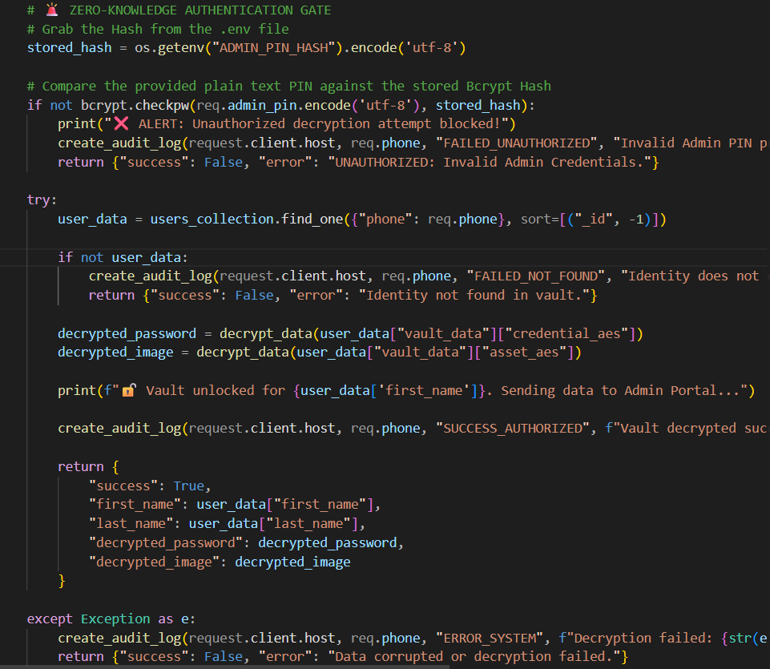
(Figure 6.1: Backend logic demonstrating the secure extraction of the .env hash and the execution of the bcrypt.checkpw evaluation.)
6.3 k-Anonymity Breach Verification
To defend against credential stuffing, the system must verify if a user's proposed password has appeared in historical data breaches. However, transmitting a user's plain-text password to a third-party API is a severe security violation. This is solved via a k-Anonymity protocol interfacing with the Have I Been Pwned (HIBP) API.
- Client-Side Hashing: Utilizing the CryptoJS library, the frontend intercepts the user's password input and generates a complete SHA-1 hash locally in the browser.
- The Prefix Query: The client separates the first 5 characters of the hash (the prefix) and sends only this prefix to the HIBP API over an encrypted HTTPS connection.
- Local Cross-Referencing: The API returns a massive list of all breached password hash suffixes that share that 5-character prefix. The client-side JavaScript then scans this localized list to see if the remainder of the user's hash matches any entry.
- Result: The system accurately determines if the password is breached without the full password or the full hash ever leaving the user's device.
6.4 Active Defense Mechanisms (Brute-Force Shield)
While cryptography protects data at rest, the system also requires active shielding to protect data in transit from automated credential guessing.
- IP-Based Rate Limiting: The FastAPI routing layer is fortified with the slowapi middleware. This creates an in-memory tracking structure that monitors incoming requests per unique IP address.
- Threshold Configuration: The /api/vault/retrieve decryption endpoint is strictly limited (e.g., maximum 5 requests per minute).
- Automated Connection Dropping: If a botnet or automated script attempts to brute-force the Admin PIN, slowapi intercepts the 6th request before it hits the database logic. The system instantly drops the connection, issues a temporary IP ban, and returns an HTTP 429 Too Many Requests status code.
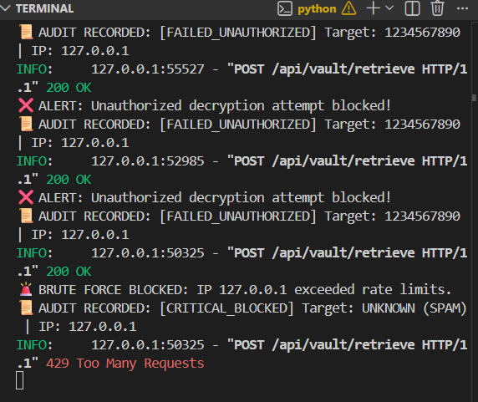

(Figure 6.2: Backend terminal logs demonstrating the slowapi rate limiter intercepting unauthorized requests and issuing 429 status codes during an automated attack simulation.)

7. Cognitive Security
Traditional security systems place the entire cognitive burden on the user, forcing them to memorize abstract, high-entropy character strings. This project introduces a "Cognitive Security" paradigm, utilizing Artificial Intelligence to actively assist the user in generating, transforming, and retaining secure credentials
7.1 Threat Intelligence & Transformation Engine
Before generating visual anchors, the system must first ensure the underlying text-based credential is cryptographically sound and free of social engineering vulnerabilities.
- Contextual NLP Scanning: The frontend utilizes compromise.js, a lightweight Natural Language Processing library, to perform real-time entity extraction on the user's password input. The engine specifically looks for predictable entities—such as calendar years (e.g., "2024", "2026"), geographical locations (e.g., "Chennai", "Bangalore"), and common names. If detected, the UI instantly warns the user that their password is vulnerable to Open-Source Intelligence (OSINT) scraping and targeted dictionary attacks.
- The AI Transformation Engine: If a user inputs a weak, easily memorable phrase (e.g., "ilovemusic"), the Transformation Engine applies deterministic algorithms to mutate the string into a high-entropy variant. This includes complex symbol replacement and passphrase-style restructuring (e.g., utilizing the CorrectHorseBatteryStaple methodology). The system generates multiple secure variations, allowing the user to select the option that best preserves their original intent while mathematically resisting brute-force decryption.
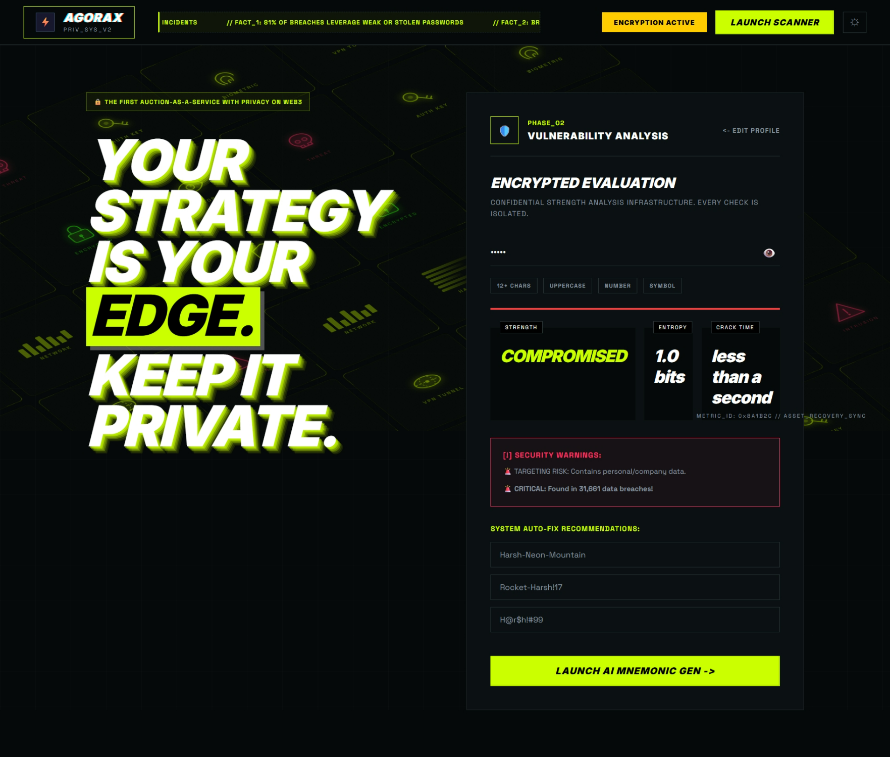
(Figure 7.1: The Glassmorphism UI displaying real-time zxcvbn entropy scoring alongside active NLP warnings preventing the use of localized personal data.)

8. Generative AI Integration
The core innovation of this architecture is the AI Visual Mnemonic Generator. Human psychology dictates that visual memory is vastly superior to rote character memorization. By anchoring a high-entropy password to a unique, highly specific AI-generated image, the cognitive recall rate increases exponentially.
- Question-Based Generation (Prompt Engineering): To prevent users from experiencing "blank canvas syndrome," the UI provides interactive selection pools. The user selects a Subject (e.g., an animal or hero), a Place (e.g., a city or vacation spot), and an Object (e.g., a musical instrument). The system concatenates these choices with dynamically generated security numbers.
  - Example Payload: Subject="Panda", Place="Paris", Object="Guitar", RNG="$88".
  - Resulting Credential: PandaParisGuitar$88.
- Local Generative AI Pipeline: The backend receives this payload and translates it into an optimized natural language prompt: "A highly detailed, cinematic image of a panda in Paris holding a guitar." Crucially, this prompt is not sent to a public API (like OpenAI), which would violate enterprise data privacy policies.
- Latent Diffusion Execution: Instead, the Python FastAPI server directly loads stabilityai/sd-turbo Model into local hardware memory via the HuggingFace diffusers library. The model executes locally, transforming the text prompt into a high-resolution base64 image array within seconds.
- Enhanced Recall: The resulting image is displayed on the frontend and offered as a secure download.

(Figure 8.1: The resulting GenAI image generated locally via the Stable Diffusion Turbo pipeline.)

9. Timeline & Agile Execution
The project utilized an 30 days Agile Software Development Lifecycle (SDLC) with one-week sprints to ensure continuous testing, modular integration, and flexibility against technical bottlenecks.
9.1 Sprint Breakdown & Milestones
- Week 1: Frontend Scaffolding & Threat Intel: Built the Glassmorphism UI and integrated zxcvbn.js for real-time entropy scoring, alongside compromise.js (NLP) and k-Anonymity protocols for breach verification.
- Week 2: Backend & Cryptography: Scaffolded the Python/FastAPI server, established AES-256 data encryption (cryptography.fernet), and deployed bcrypt authentication shielded by slowapi rate-limiting.
- Week 3: AI Pipeline & Cloud Architecture: Integrated the local stabilityai/sd-turbo Generative AI model for visual mnemonics and provisioned a segregated, remote MongoDB Atlas cluster.
- Week 4: Admin Portal & Finalization: Developed the restricted decryption portal featuring 15-second ephemeral memory locks, conducted system optimization, and finalized technical documentation.
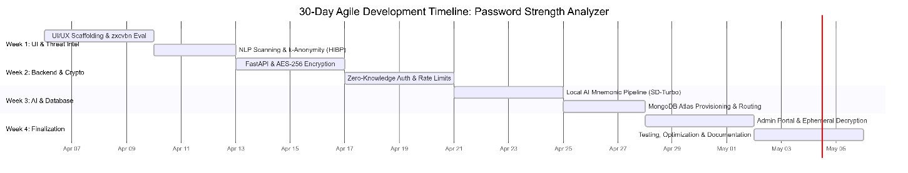
(Figure 9.1: Visual representation of the Agile development timeline, highlighting the modular progression from frontend Threat Intelligence to backend Zero-Trust execution.)
9.2 Version Control & Code Hygiene
Throughout the SDLC, strict code hygiene and version control protocols were maintained. The project utilized Git for local tracking, ensuring that experimental features (such as the AI integration) were developed on isolated branches before being merged into the primary production codebase. Furthermore, sensitive environment variables (.env) and Python cache files (__pycache__) were strictly excluded via .gitignore to prevent accidental credential leakage, adhering to enterprise DevSecOps standards.

10. System Interfaces & Proof
The following section provides visual validation of the dual-node architecture discussed in Section 4. It demonstrates the seamless integration of the Glassmorphism frontend, the generative AI pipeline, and the backend Zero-Trust defense mechanisms.
10.1 The Client Node: Threat Intelligence & Entropy Analysis
The primary user interface is designed to reduce cognitive friction while maximizing security awareness. The deployment of a Glassmorphism aesthetic ensures a modern, accessible experience. Behind the UI, the system actively computes cryptographic entropy and parses user input for social-engineering vulnerabilities.
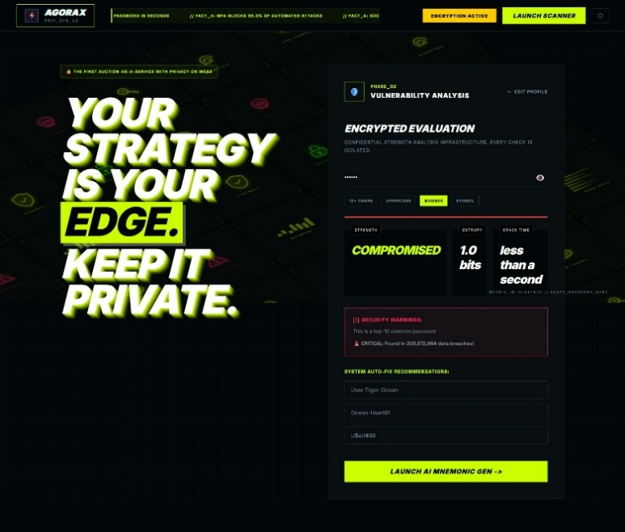
(Figure 10.1: Core Evaluation Interface. The frontend Client Node displaying real-time password strength evaluation. The underlying zxcvbn.js engine calculates crack-time estimation, while the NLP layer actively scans for locational or personal identifiers to mitigate Open-Source Intelligence (OSINT) attacks.)
10.2 Generative AI Mnemonic Pipeline
To solve the vulnerability of password amnesia, the system shifts the user's cognitive anchor from a randomized text string to a highly specific, AI-generated visual mnemonic.

(Figure 10.2: Cognitive Visual Anchor Generation. The resulting high-fidelity image generated entirely locally via Python FastAPI backend using the stabilityai/sd-turbo Latent Diffusion Model.)
10.3 The Zero-Trust Admin Portal
Administrative access to encrypted credentials bypasses standard retrieval methods. The Admin Portal requires Zero-Knowledge authentication (bcrypt) to access the vault. To prevent physical security breaches (e.g., shoulder surfing or unauthorized screen captures), the decrypted AES-256 payload is only held in memory temporarily before an automated auto-lock script flushes the DOM.
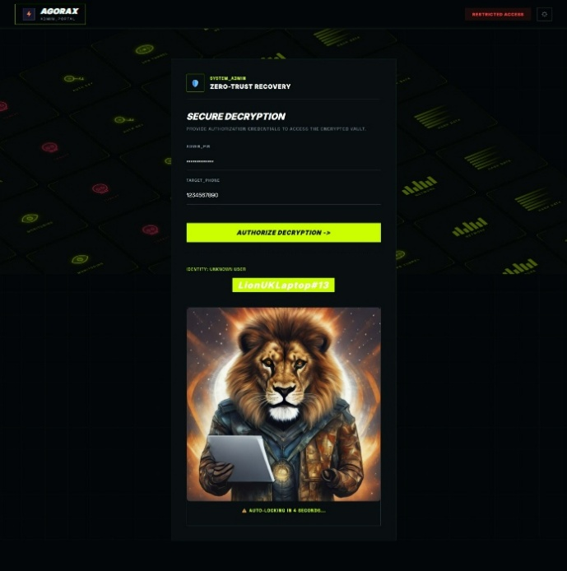
(Figure 10.3: Ephemeral Decryption Interface. The restricted Admin Portal. Upon successful bcrypt validation of the Master PIN, the system performs an in-memory AES-256 decryption of the target user's identity. The data remains visible for a strict 15-second ephemeral window before the interface automatically locks.)
10.4 Immutable Audit Logging & Active Defense
A secure frontend is irrelevant if the backend routing is vulnerable to automated credential guessing. The system relies on slowapi to monitor IP traffic and a custom logging engine to record all interactions.
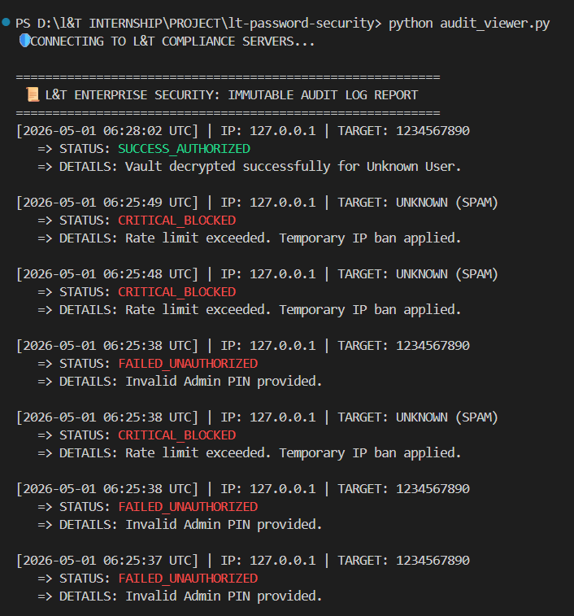
(Figure 10.4: Active Threat Mitigation and Compliance Logging. Backend terminal execution logs demonstrating two critical Zero-Trust features: (1) The immutable audit engine successfully recording an authorized data retrieval [SUCCESS_AUTHORIZED], and (2) The IP-based Brute-Force shield intercepting an automated attack, dropping the connection, and returning an HTTP 429 (Too Many Requests) status code.)

11. Challenges & Resolutions
Developing the Zero-Trust architecture and integrating local Generative AI presented complex engineering roadblocks that required iterative debugging, architectural pivoting, and asynchronous optimization.
11.1 Challenge: AI Model VRAM Exhaustion & Event Loop Blocking
- The Problem: The resource-intensive sd-turbo model blocked the FastAPI ASGI event loop, halting concurrent API requests, and caused Out-Of-Memory (OOM) crashes on non-GPU hardware.
- The Resolution: Implemented PyTorch dynamic device mapping (torch.cuda.is_available()) for graceful CPU fallback. To prevent event loop blocking, the AI generation function was decoupled using asyncio and FastAPI's BackgroundTasks, offloading the workload to a separate worker thread.
11.2 Challenge: Database Latency with Base64 Payloads
- The Problem: Pushing massive Base64 image payloads synchronously to the MongoDB Atlas cluster caused severe network bottlenecks and frontend timeout errors.
- The Resolution: The database connection layer was refactored using an asynchronous driver (motor). Additionally, Base64 strings were optimized and compressed prior to AES-256 encryption, drastically reducing payload size and preventing UI blocking.
11.3 Challenge: Zero-Knowledge State Management
- The Problem: Initial prototypes incorrectly attempted to decrypt the stored Master Admin hash for verification, creating a critical security vulnerability and violating Zero-Knowledge principles.
- The Resolution: The authentication middleware was redesigned to hold the plain-text input strictly in volatile memory. It exclusively uses bcrypt.checkpw() to mathematically verify the match without revealing the secret, followed by an immediate garbage collection flush.
11.4 Challenge: Rate Limiter Loopback Configuration
- The Problem: The slowapi brute-force shield caused an immediate self-denial-of-service during local testing by indiscriminately blocking the developer's localhost IP (127.0.0.1).
- The Resolution: Modified the proxy configuration to accurately parse X-Forwarded-For network headers. Environment-specific exceptions were also added to the .env file, allowing dynamic threshold adjustments between development and production states.

12. Key Learnings
Key Learnings & Competencies Acquired
The L&T EduTech internship provided a rigorous environment to transition from theoretical computer science concepts to applied, enterprise-grade software engineering. The core competencies acquired include:
- Applied Cryptography: Transitioned from basic hashing concepts to implementing production-ready AES-256 symmetric encryption and bcrypt Zero-Knowledge proofs.
- Zero-Trust Architecture: Learned to design secure backend environments, specifically utilizing .env isolation, secure asynchronous API routing (FastAPI), and IP-based rate limiting (slowapi) to actively mitigate automated attacks.
- Generative AI Integration: Gained hands-on experience working with HuggingFace diffusers. Learned to successfully provision, optimize, and execute local Latent Diffusion Models (stabilityai/sd-turbo) via Python, avoiding reliance on insecure third-party APIs.
- Data Privacy & Compliance: Developed a deep understanding of k-Anonymity protocols and the necessity of immutable, segregated audit logging for corporate compliance standards.
- Full-Stack Optimization: Learned to resolve complex asynchronous bottlenecks, specifically decoupling heavy machine learning tasks from the main ASGI event loop to ensure system scalability.

13. Future Scope & Scalability
While the current architecture successfully mitigates the primary vulnerabilities of human-centric authentication, the system is designed to be scalable for future enterprise integration:
- Multi-Factor Authentication (MFA): The current Zero-Knowledge backend is primed to integrate Time-based One-Time Passwords (TOTP) or biometric verification (WebAuthn) as a secondary access layer for the Admin Portal.
- Enterprise Active Directory Integration: The system can be scaled to interface with existing corporate directories (e.g., LDAP, Azure AD), allowing enterprise IT departments to automatically generate AI visual mnemonics for employee onboarding.
- Adaptive Threat Intelligence: Future iterations could upgrade the static IP rate-limiter to a machine-learning anomaly detection engine, capable of identifying and blocking sophisticated, distributed botnet attacks in real time based on behavioral heuristics.

14. Conclusion
The Password Strength Analyzer with AI Visual Mnemonics successfully demonstrates the viability of merging cutting-edge Generative AI with rigorous, Zero-Trust cybersecurity protocols. By shifting the cognitive burden of authentication from complex character strings to vivid, AI-generated visual mnemonics, the application vastly improves user experience without compromising cryptographic integrity. Furthermore, the integration of AES-256 encryption, Zero-Knowledge backend authentication, and active Brute-Force shields ensures the system meets strict commercial compliance standards.
This internship project provided invaluable hands-on experience in full-stack engineering, applied cryptography, and threat mitigation, resulting in a highly robust, scalable security product.

15. Acknowledgements
I sincerely thank my mentor, Dhikhi T, alongside the coordinators at L&T for offering this exceptional opportunity. I am deeply grateful for their guidance, technical feedback, and the exposure to enterprise-level architecture provided throughout this 30-day internship journey. This experience has been pivotal in advancing my competencies in modern software engineering and cybersecurity.

